**SCHOOL OF COMPUTER SCIENCE**

**UNIVERSITY OF PETROLEUM AND ENERGY STUDIES**

**DEHRADUN, UTTARAKHAND**



**DATA COMMUNICATION AND NETWORKS LAB**

**LABORATORY FILE**

**(2024-2025)**

**For**

**Vth Semester**

**Submitted To: Submitted By:**

Prof. Abhishek Yadav Mr. Akshat Negi

Assistant Professor S.S. 500106533(SAP ID)

[Vth Semester] R2142220414(Roll No.)

School of Computer Sciences B.Tech. CSF (Batch-1)

**LAB EXPERIMENT – 6**

**Hub - STAR TOPOLOGY**

To set up a **star topology** with 6 PCs connected through a **hub**.

**Set Up the Devices**

1. Open **Cisco Packet Tracer**.
2. Drag and drop:
   * **1 Hub** (e.g., Generic Hub).
   * **6 PCs**.
3. Use straight-through cables to connect:
   * Each PC to the Hub port using straight-through cables.

**Assign IP Addresses to PCs**

Each PC needs an IP address. Use the **IP Configuration tab** for each PC:

**Steps for Each PC:**

1. **Click on a PC** (e.g., PC0).
2. Navigate to **Desktop > IP Configuration**.
3. Set the following IP addresses:

|  |  |  |
| --- | --- | --- |
| **PC Name** | **IP Address** | **Default Gateway** |
| PC0 | 10.0.0.1 | 10.0.0.254 |
| PC1 | 10.0.0.2 | 10.0.0.254 |
| PC2 | 10.0.0.3 | 10.0.0.254 |
| PC3 | 10.0.0.4 | 10.0.0.254 |
| PC4 | 10.0.0.5 | 10.0.0.254 |
| PC5 | 10.0.0.6 | 10.0.0.254 |

**PC Configuration Setup**

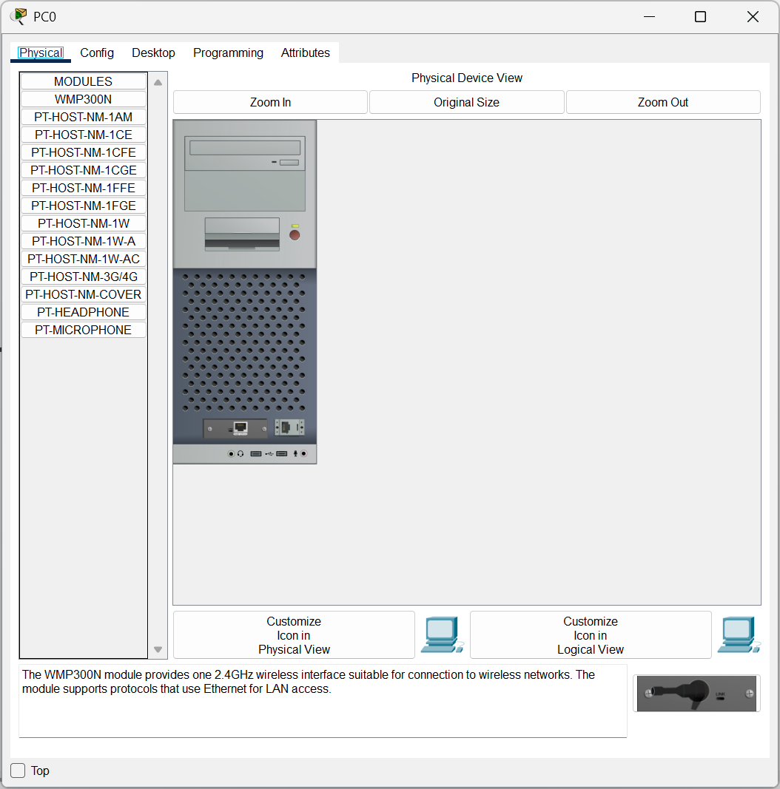

Configure PC0 with giving IP Address as **10.0.0.1**

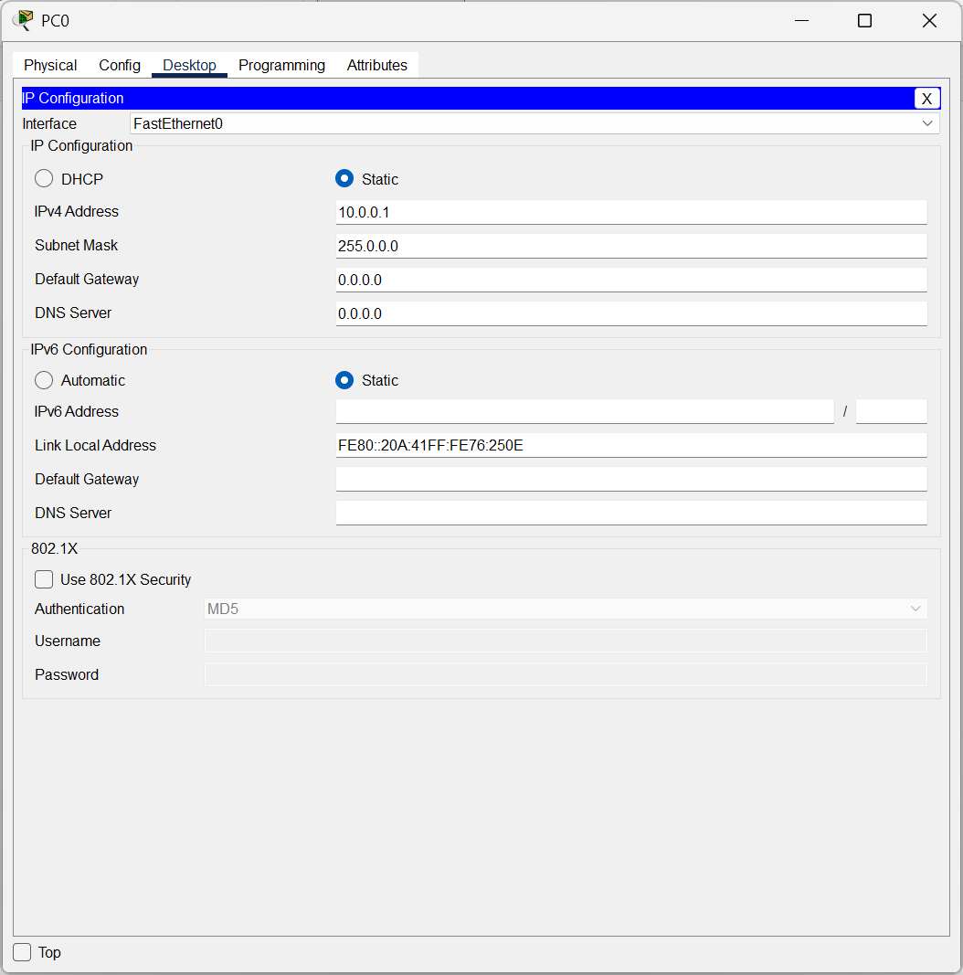

**Physical Representation of a Hub**

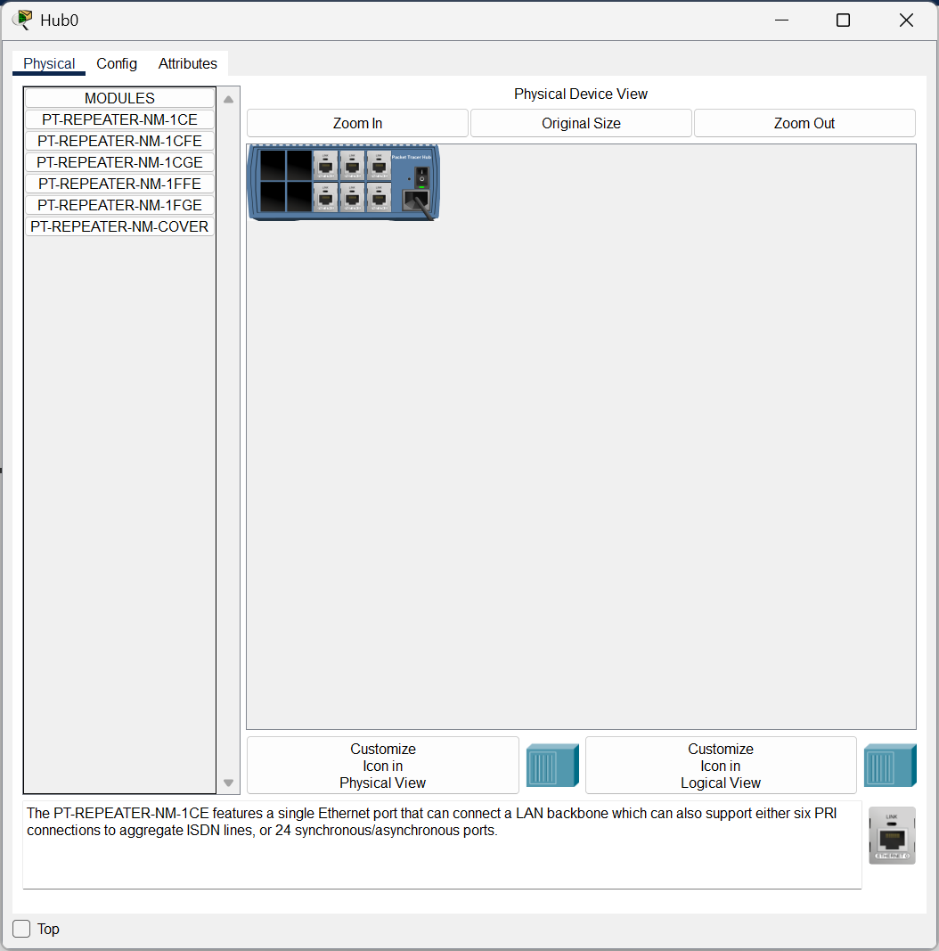

**CISCO PACKET TRACER DIGITAL REPRESENTATION**

***Representation of 6 PCs connected through Hub to each other following Star Topology.***

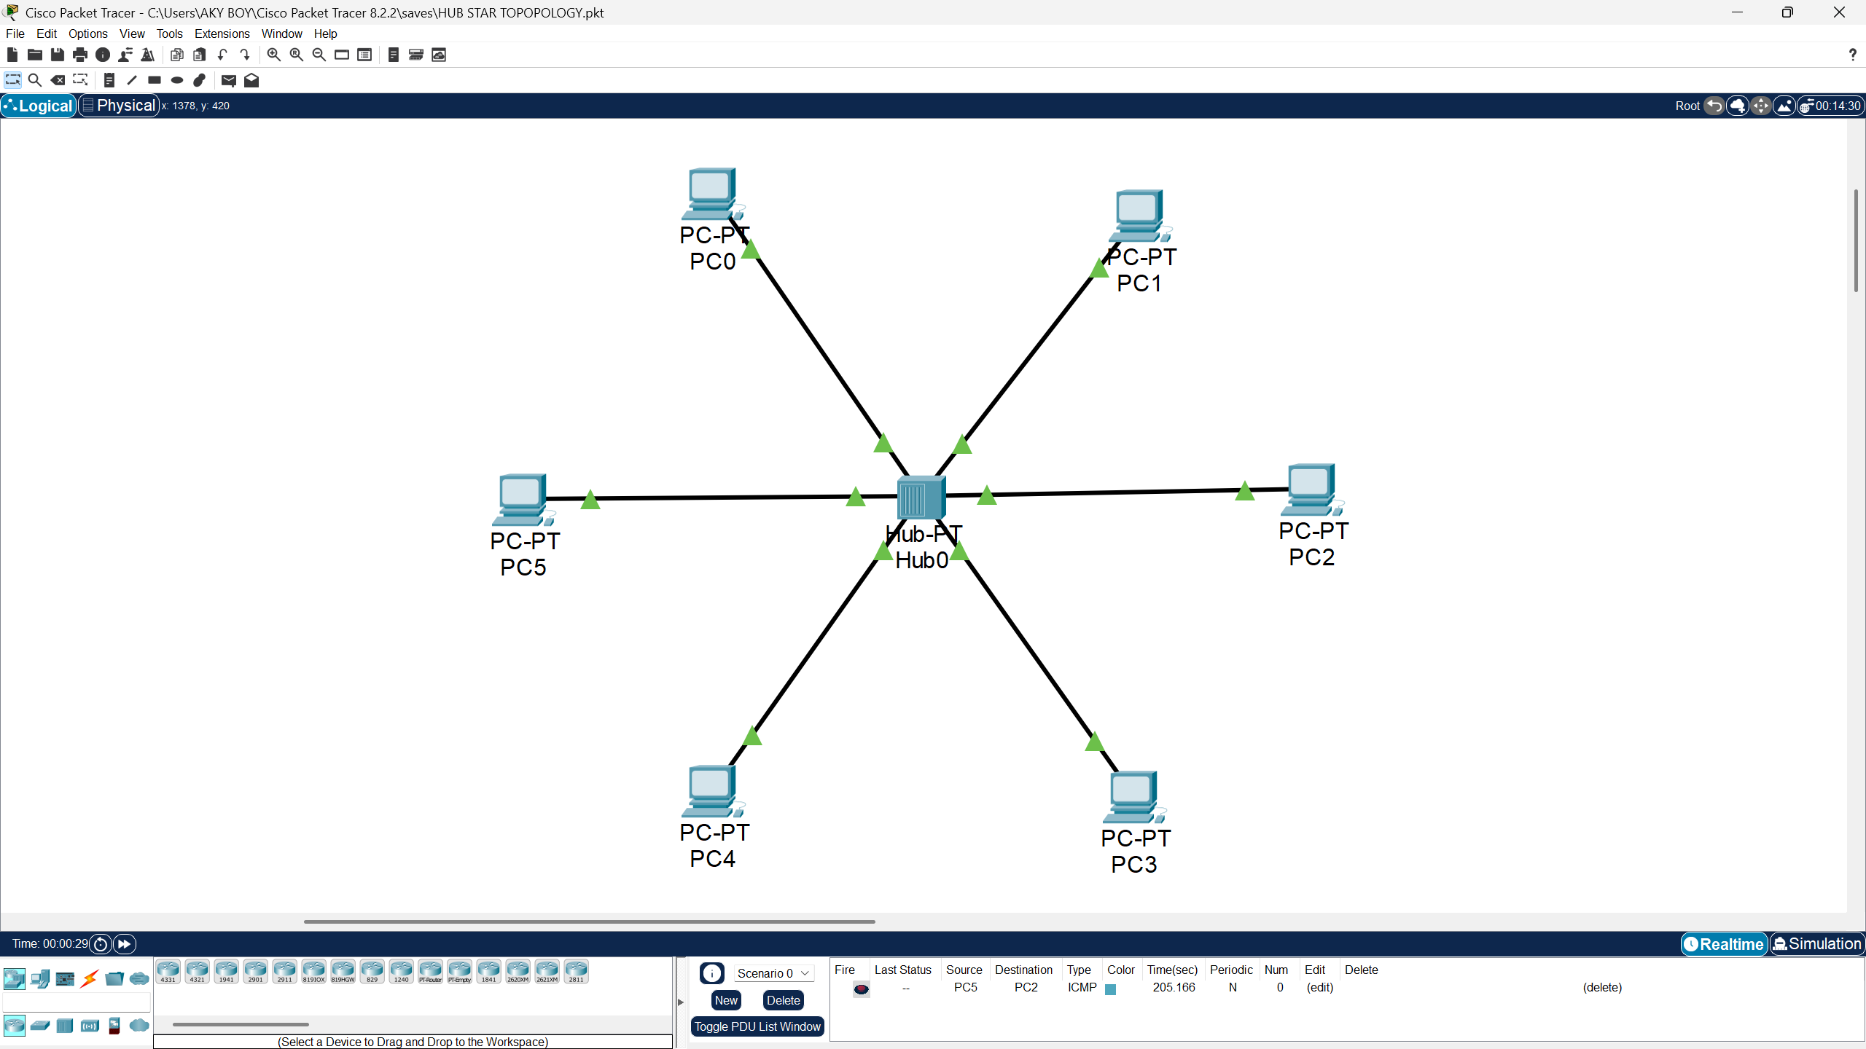

**Switch - STAR TOPOLOGY**

**Set Up the Devices**

1. Open **Cisco Packet Tracer**.
2. Drag and drop:
   * **1 Switch**.
   * **6 PCs**.
3. Use **straight-through cables** to connect:
   * Each PC to one of the switch ports (e.g., FastEthernet 0/1 to FastEthernet 0/6).

**Assign IP Addresses (Static Configuration)**

Manually assign IP addresses to each PC using the **IP Configuration tab**:

**Steps for Each PC:**

1. **Click on a PC** (e.g., PC0).
2. Navigate to **Desktop > IP Configuration**.
3. Assign the following settings:

|  |  |  |
| --- | --- | --- |
| **Device** | **IP Address** | **Default Gateway** |
| PC0 | 10.0.0.1 | 0.0.0.0 |
| PC1 | 10.0.0.2 | 0.0.0.0 |
| PC2 | 10.0.0.3 | 0.0.0.0 |
| PC3 | 10.0.0.4 | 0.0.0.0 |
| PC4 | 10.0.0.5 | 0.0.0.0 |
| PC5 | 10.0.0.6 | 0.0.0.0 |

**PC Configuration Setup**

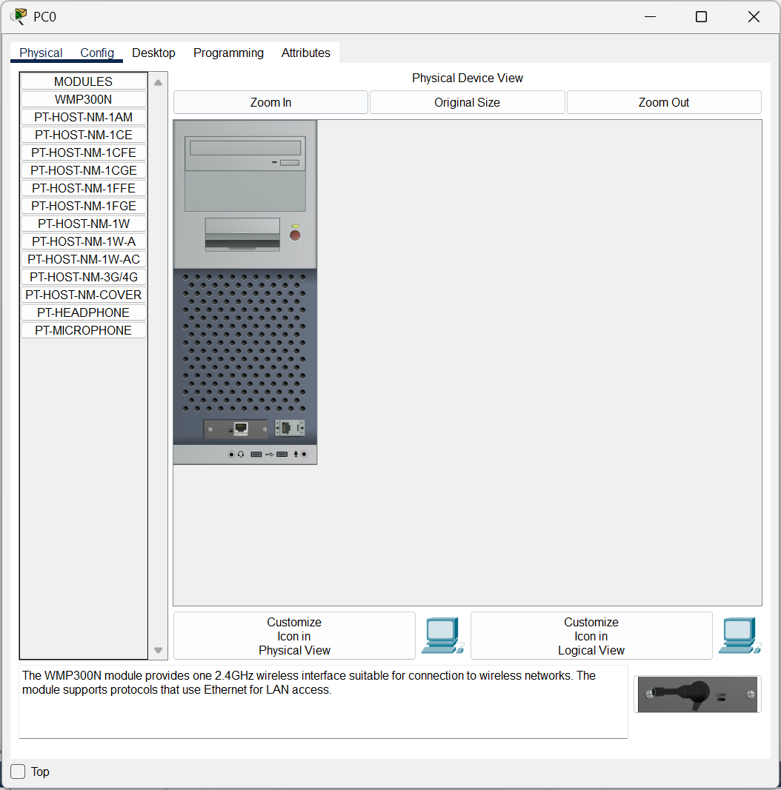

Configure PC0 with giving IP Address as **10.0.0.1**

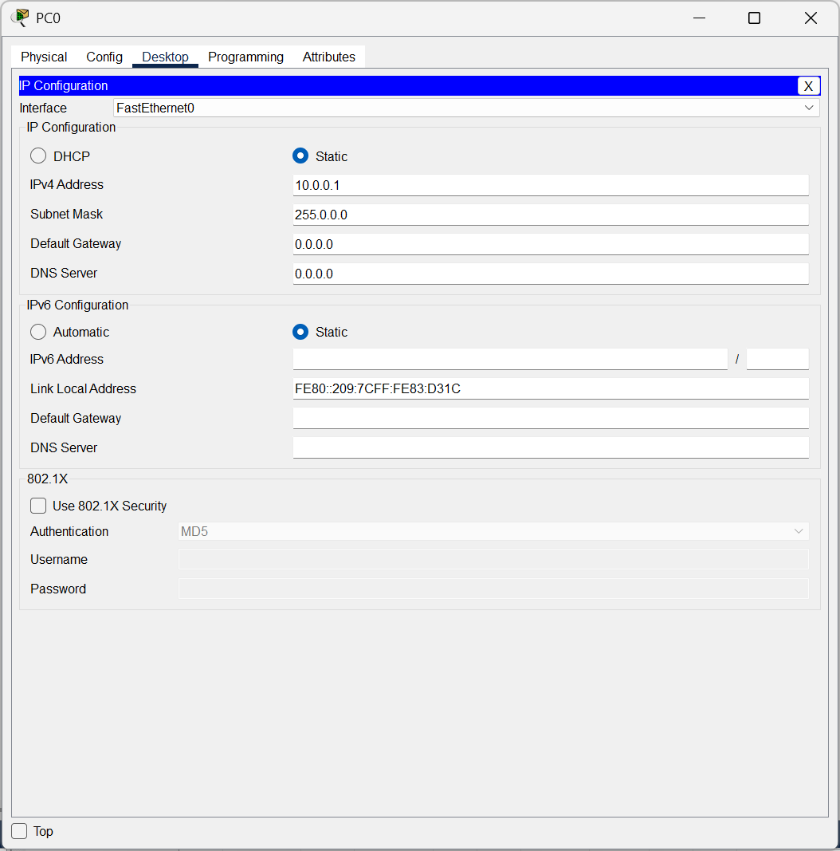

Connect the Switch to the PCs by connecting switch with automatic cables.

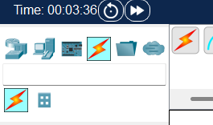

Drag and drop the Switch and connect them with PCs

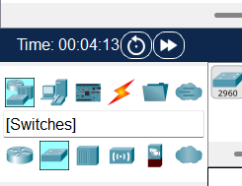

**CISCO PACKET TRACER DIGITAL REPRESENTATION**

***Representation of 6 PCs connected through switches to each other following Star Topology.***

